2015 Eagle’s Wings
UnBEARable Fun! Run

Youth Minister Information Sheet

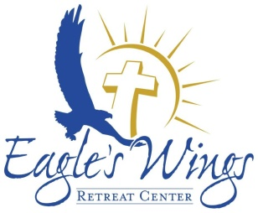
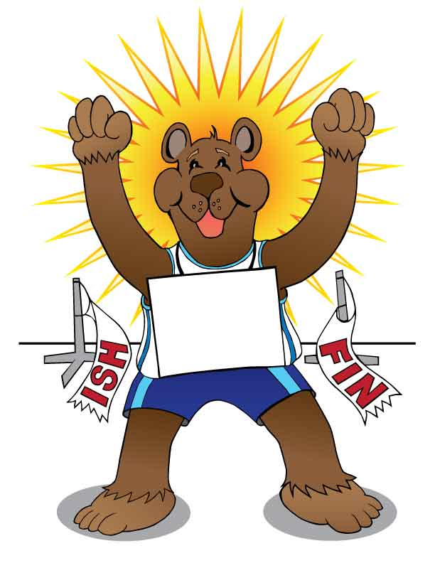
Can’t come as a group?
Individual racers welcome. Please visit:
http://unbearablefunrun.weebly.com

Special guest appearance by 2012 Olympic Silver Medalist Leo Manzano!

Dear Youth Minister,

Eagle’s Wings Retreat Center is sponsoring a Fun Run with the youth in mind!

What?
This Fun Run is a 5K throughout the beautiful grounds of Eagle’s Wings Retreat Center with a couple fun pit stops including a Bear Crawl, a Bear Roll, a Bear Scratch, A Bear Style Fishing Post and a Honey Station. Cleo the Bear will be at the starting/finish line and we will wrap up with music, our climbing wall and Bear Claws after the race.

When?
Saturday, December 5th starting at 9:30 AM.

Why?
The goal of the Eagle’s Wings UnBEARable Fun Run is to bring youth groups, and members of the community together to have fun and generate funds for a worthy cause. Youth Groups are asked to challenge their teens to collect sponsorship pledges for their run with both a Youth Group Incentive package and an Individual Incentive Package:

Youth Group Incentives
We know you are busy, juggling a ton of balls and want to be a leader for our youth today. That is why we’ve structured the Fun Run as a challenge against other Youth Groups with a generous incentive package.
Awards are based on highest average contribution per participant per youth group.
1st Place: 20% discount on EWRC accommodations + a free ice cream party @ your next retreat at Eagle’s Wings
2nd Place: Free pizza party + free ice cream party @ your next retreat at Eagle’s Wings
3rd Place: Free ice cream party @ your next retreat at Eagle’s Wings

Individual Prizes:
Awarded to the highest money received
1st Place: $100 Visa Gift Card
2nd Place: $50 Visa Gift Card
3rd Place: $25 Gift Card

Registration Deadline: Please submit by Nov. 16 to ensure runners will get a T-shirt
Please submit the following paperwork to the Eagle’s Wings office at P.O. Box 248; Burnet, TX 78611
Parish registration form and Team roster
Medical release forms for all participants
Payment (checks made payable to Eagle’s Wings Retreat Center)

